ENGINEER 1C03 - Engineering Design & Graphics

Engineering 1 Cornerstone Design Project

Instructor: Dr. Nease

**Milestone 1**

Team **13**

Lab Section**: L03**

Vineeth Balachandran – balacv1 – 400238031

Yuntian Wang – wangy716 – 400234676

Tianze Zhang – zhant22 – 400208135

Jinnan Cheng – chengj64 – 400226963

As a future member of the engineering profession, the student is responsible for performing the required work in an honest manner, without plagiarism and cheating. Submitting this work with my name and student number is a statement and understanding that this work is my own and adheres to the Academic Integrity Policy of McMaster University and the Code of Conduct of the Professional Engineers of Ontario.

Submitted by [Vineeth Balachandran, 400238031]

Signature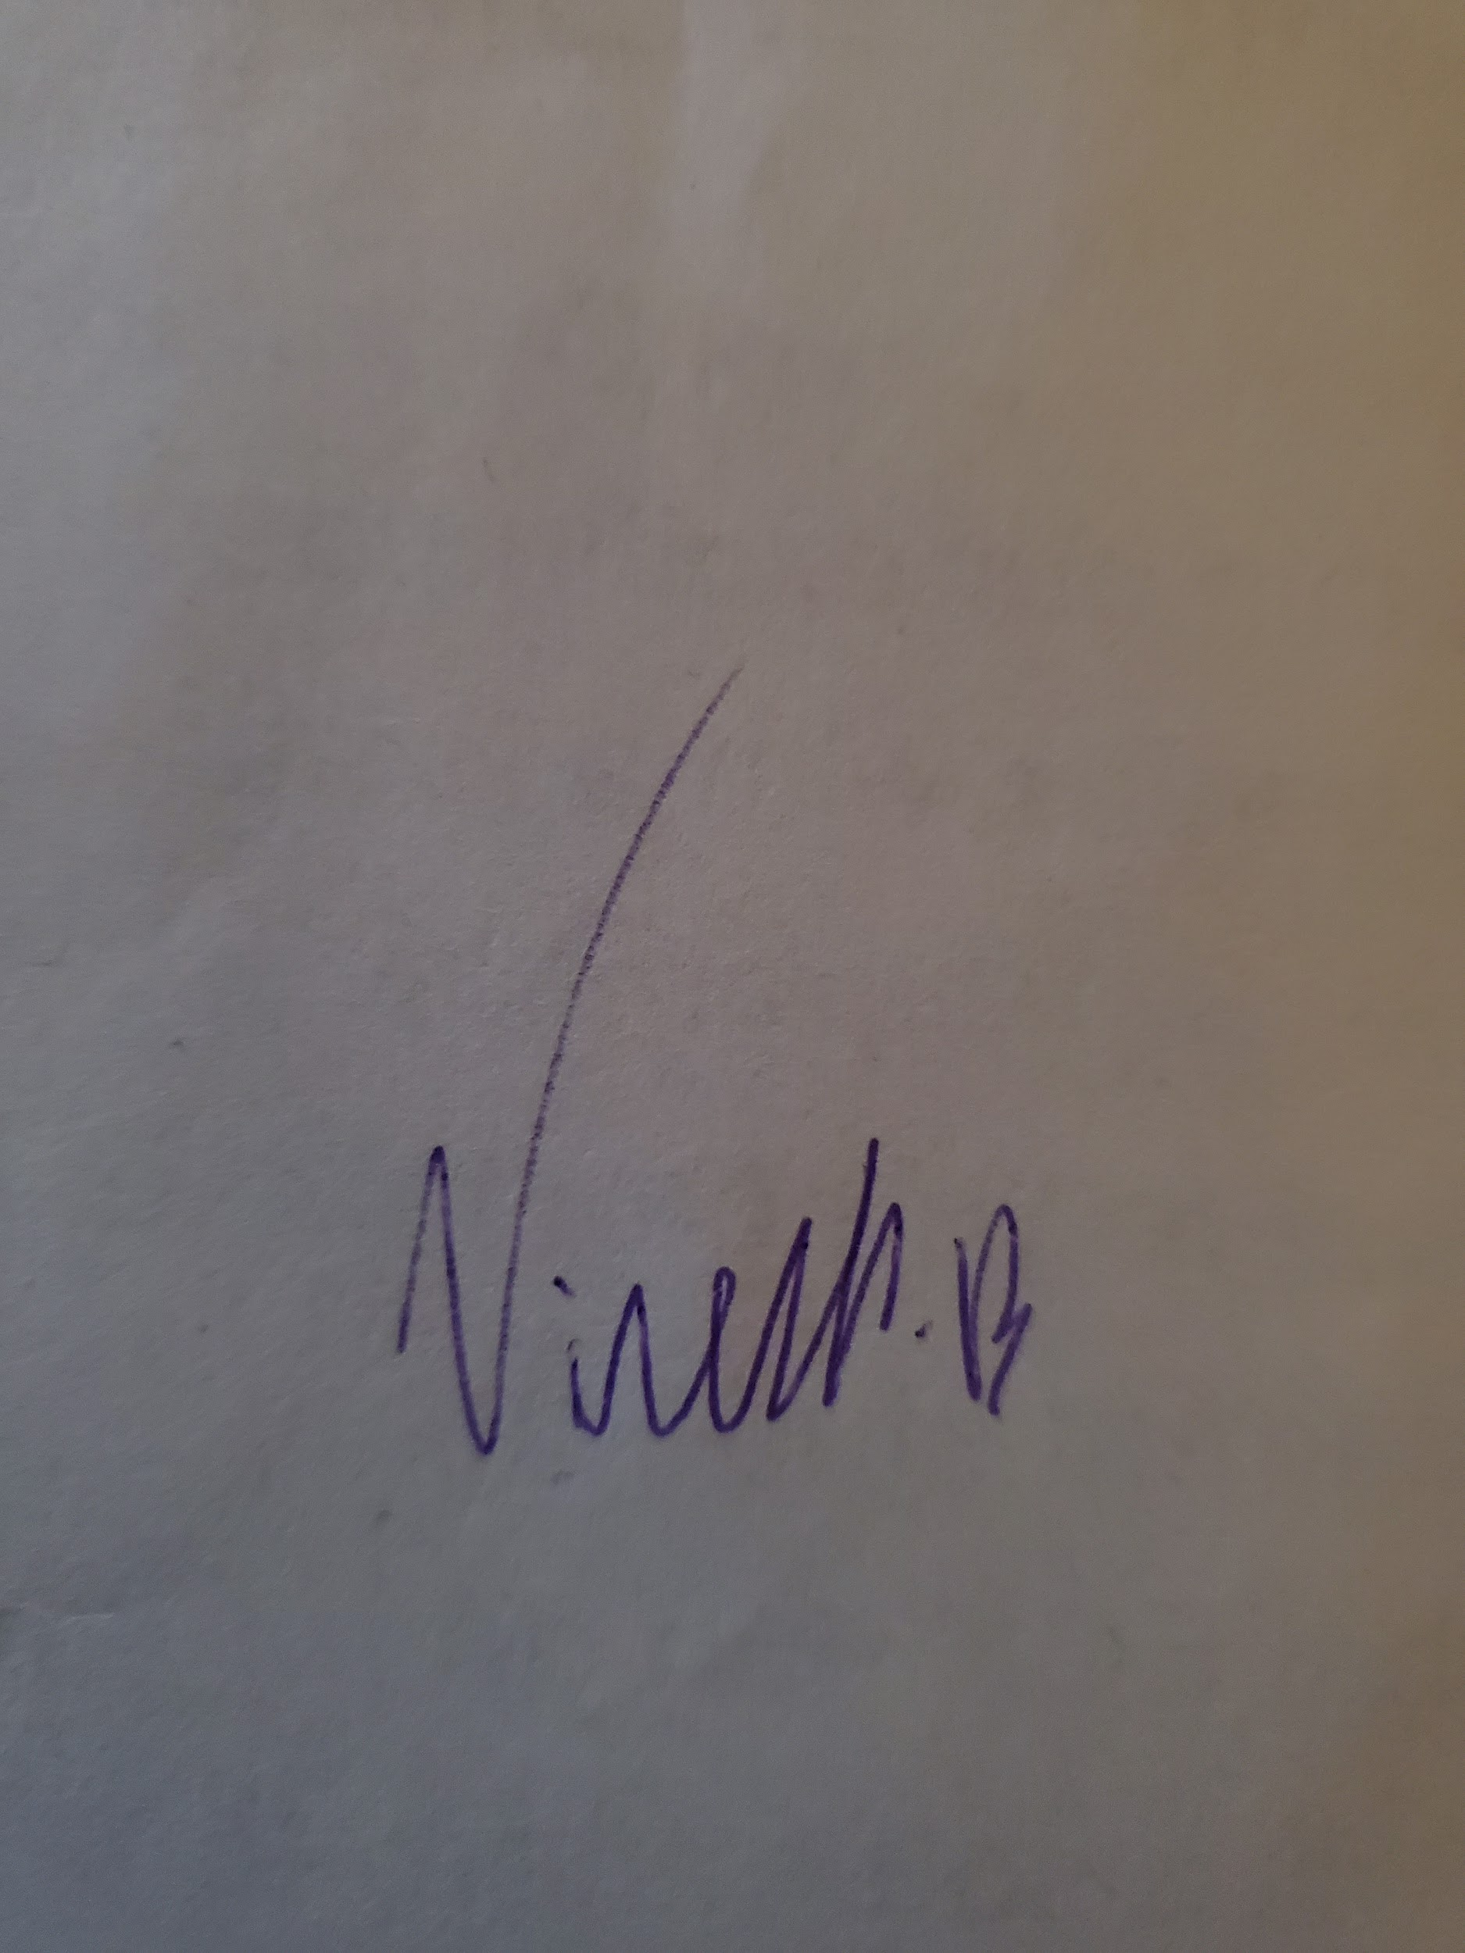

As a future member of the engineering profession, the student is responsible for performing the required work in an honest manner, without plagiarism and cheating. Submitting this work with my name and student number is a statement and understanding that this work is my own and adheres to the Academic Integrity Policy of McMaster University and the Code of Conduct of the Professional Engineers of Ontario.

Submitted by [Yuntian Wang, 400234676]

Signature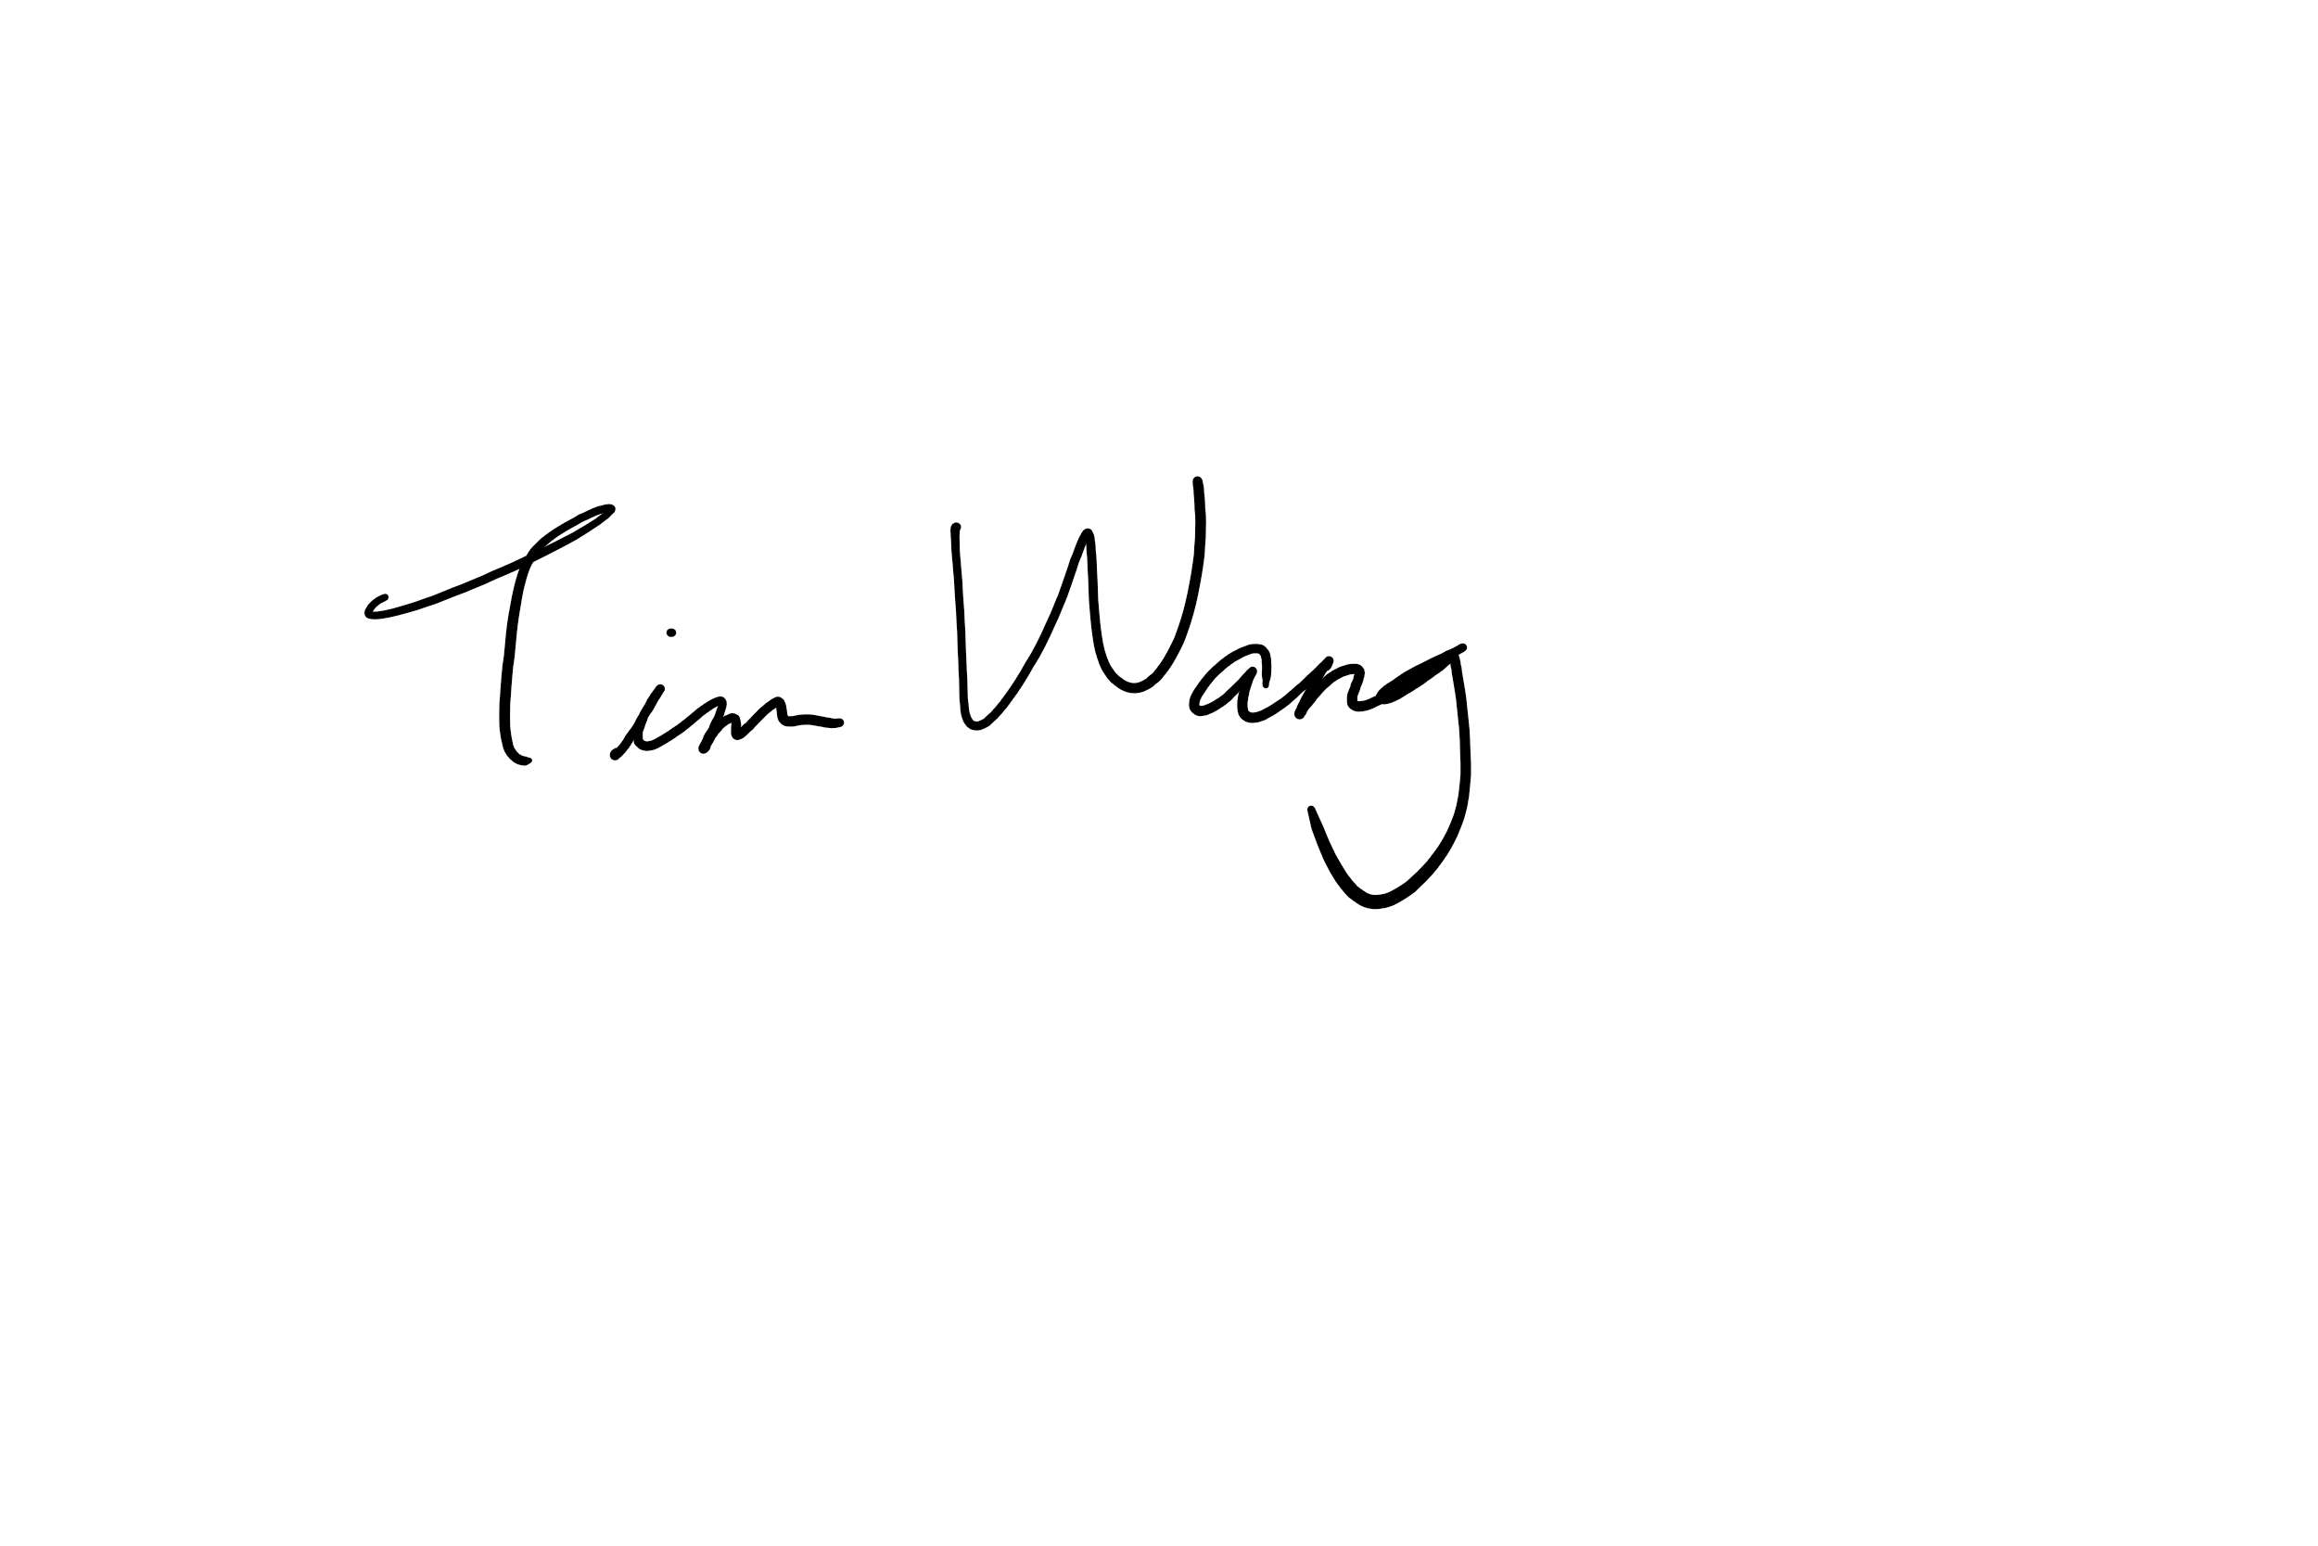

As a future member of the engineering profession, the student is responsible for performing the required work in an honest manner, without plagiarism and cheating. Submitting this work with my name and student number is a statement and understanding that this work is my own and adheres to the Academic Integrity Policy of McMaster University and the Code of Conduct of the Professional Engineers of Ontario.

Submitted by [Tianze Zhang, 400208135]

Signature 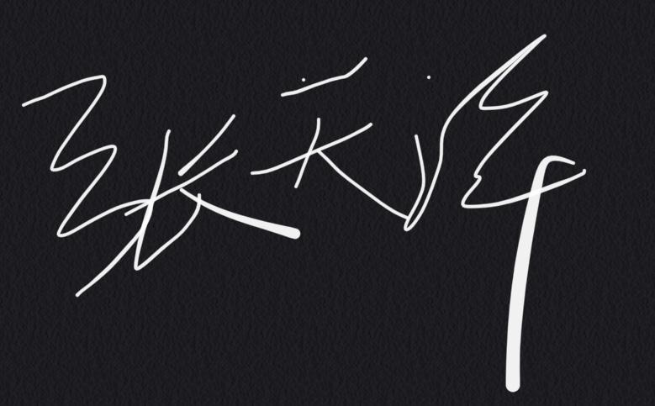

As a future member of the engineering profession, the student is responsible for performing the required work in an honest manner, without plagiarism and cheating. Submitting this work with my name and student number is a statement and understanding that this work is my own and adheres to the Academic Integrity Policy of McMaster University and the Code of Conduct of the Professional Engineers of Ontario.

Submitted by [Jinnan Cheng, 400226963]

Signature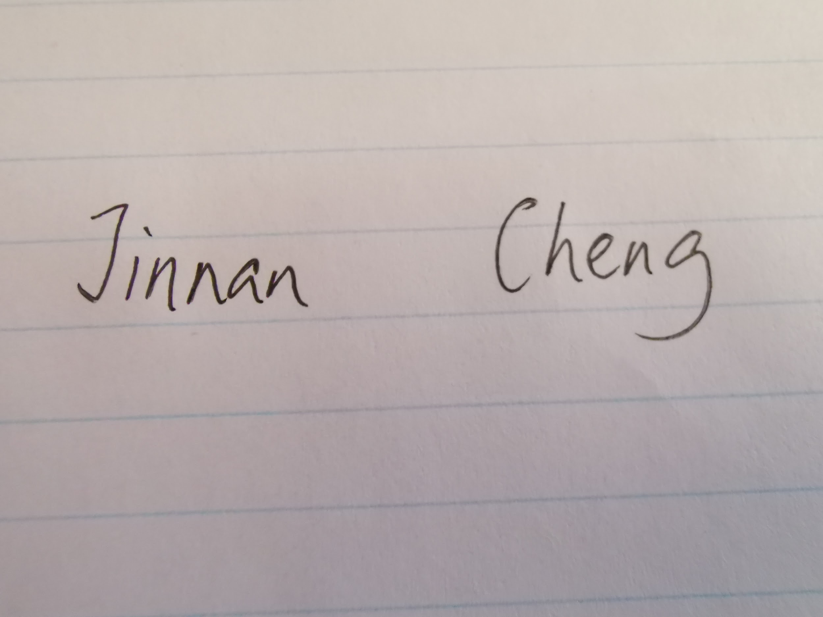

# 

# Preliminary Design Sketches

1. Plan A,B

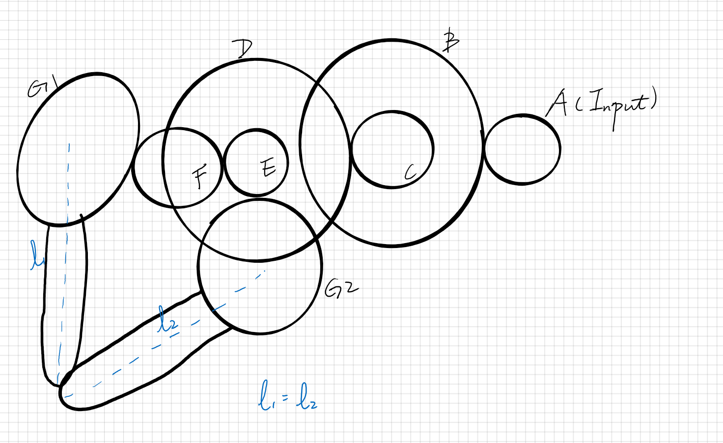

1. Plan C

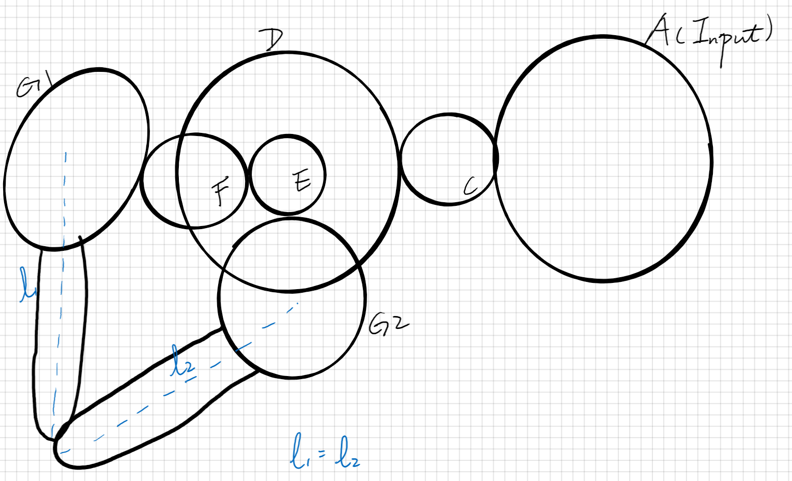

# 

# Documentation of Plan A Gearing Mechanism

## Multiview Sketch

1. Hand Drawn Sketch

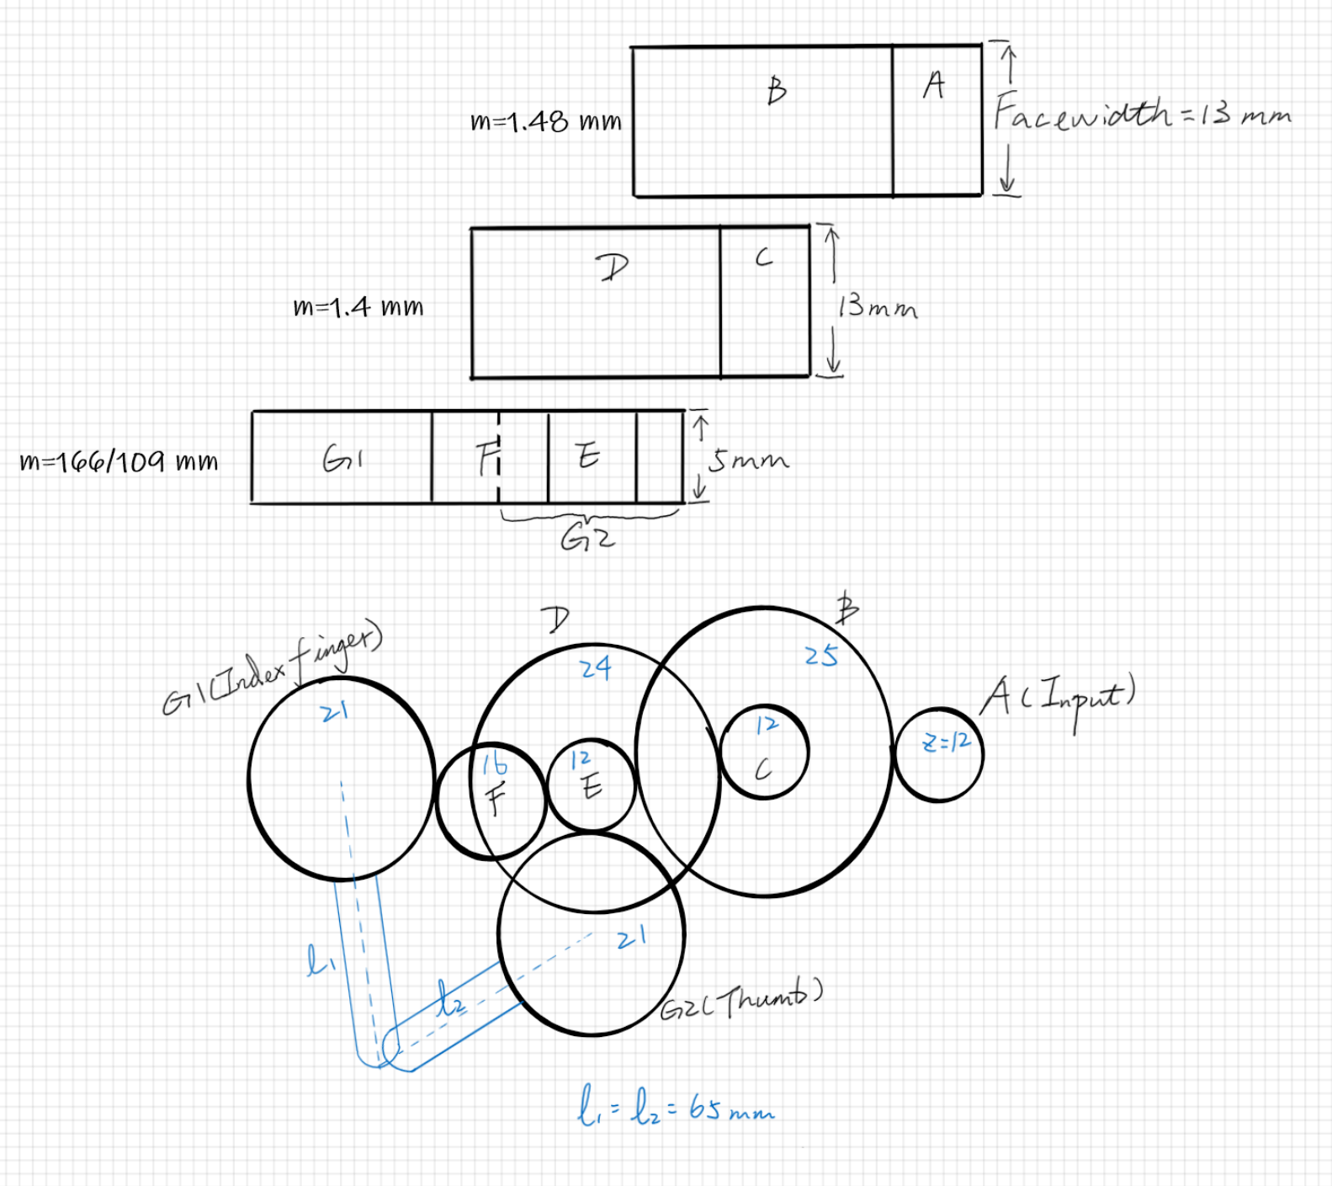

1. *Additional Sketch from Inventor

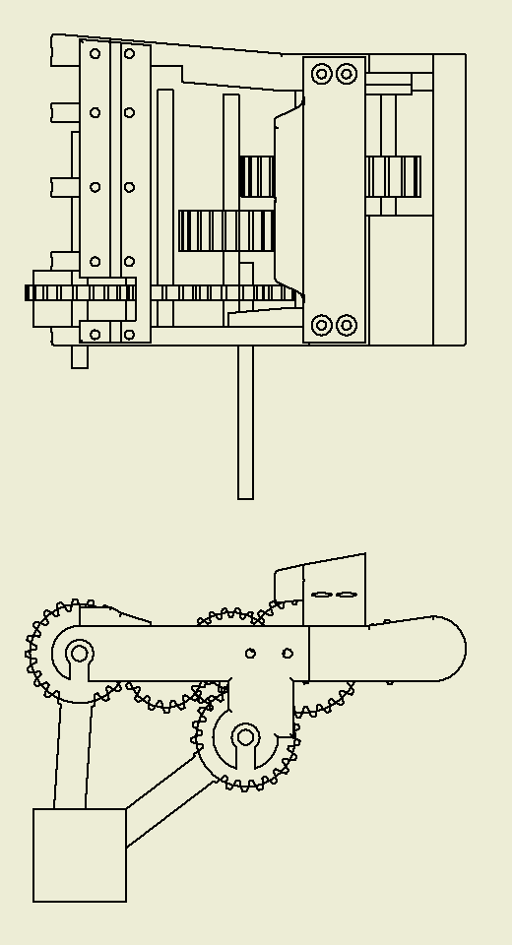

## Hand Calculations

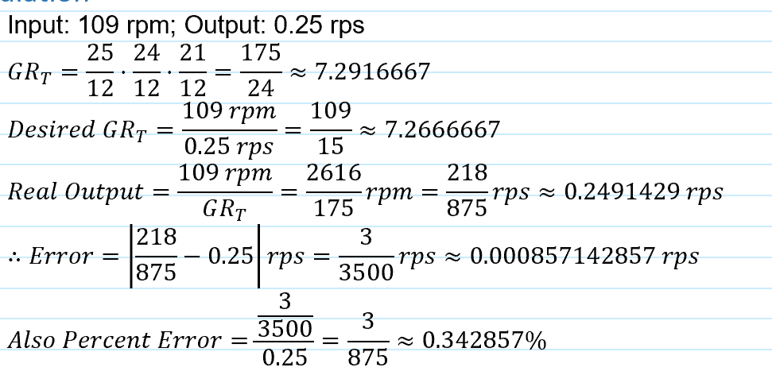

## Gear Design Parameters

| Gear Name | Type of Gear | Connection to Preceding Gear | | Pitch Diameter (mm), D | Module (mm/tooth), m | Number of Teeth, z |
| --- | --- | --- | --- | --- | --- | --- |
| Type | Name |
| A | Spur | N/A | N/A | 17.76 | 1.48 | 12 |
| B | Spur | mesh | A | 37 | 1.48 | 25 |
| C | Spur | axial | B | 16.8 | 1.4 | 12 |
| D | Spur | mesh | C | 33.6 | 1.4 | 24 |
| E | Spur | axial | D | 18.276 | 1.523 | 12 |
| F | Spur | mesh | E | 24.368 | 1.523 | 16 |
| G1 | Spur | mesh | F | 31.983 | 1.523 | 21 |
| G1 | Spur | mesh | E | 31.983 | 1.523 | 21 |